Introduction - Depreciation is the process of systematically reducing the recorded cost of an asset until it reaches its salvage value or zero value.

Straight Line Method - To calculate depreciation using the straight-line method, we subtract the asset's salvage value from its cost. The result is the depreciable basis or the amount that can be depreciated. Divide this amount by the number of years in the asset's useful lifespan.

Highlights – Asset Cost & Additional Assets cost was already available in sheet.

Actionable – To find exact or actual asset price, we will SUM the value of Asset Cost and Additional Asset Cost.

Insights - In case of no scrap value, we need to mention the value and if not aware we should mention value as 0 to avoid any error in the calculation.

Key Findings - Life Span is mentioned as 10 years so once calculated it will get the below artifacts –

* Depreciation / Year as per Straight Line Method
* Depreciation Percentage
* Total Depreciation for Its Life Span
* Depreciated Book Value After Its Life Span
* Balance Amount

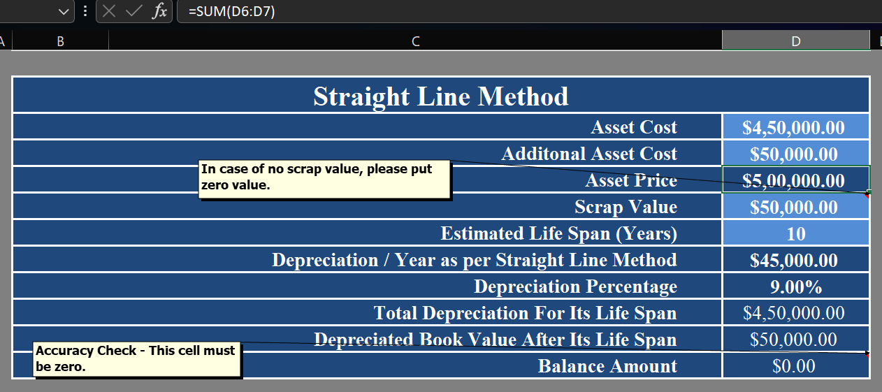

Diminishing Balance Method – It is known as reducing balance method as well. It records higher depreciation in the early years of an asset's life and lower depreciation in the later years. It's often used for assets that depreciate quickly.

Highlights – Asset Cost & Additional Assets cost was already available so by adding these values we can simply figure out the depreciation schedule.

Key Findings – While calculating the diminishing depreciation, we get the values of given span (estimated life span).

Insights - In diminishing depreciation calculation the scrap value cannot be zero.

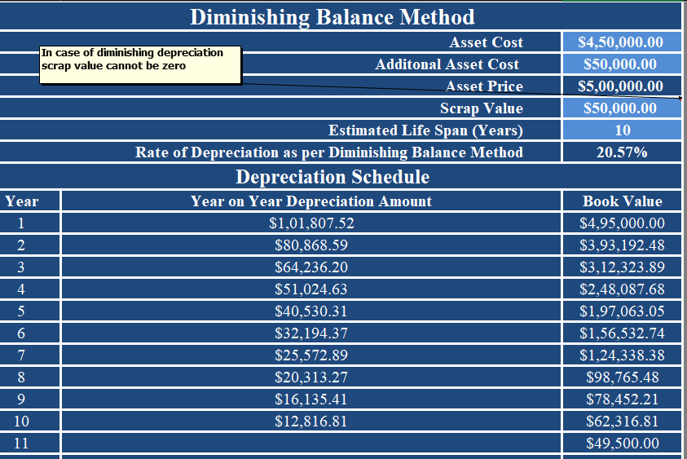

Conclusion - depreciation is a critical accounting practice that systematically allocates the cost of a fixed asset over its useful life, allowing businesses to accurately reflect the declining value of their assets on their financial statements, ultimately impacting taxable income and providing a more realistic picture of profitability by spreading the asset cost over time.